**Research Assistant**

**Antalya Bilim University**

**Tourism Faculty**

[feridun.aydinli@antalya.edu.tr](mailto:feridun.aydinli@antalya.edu.tr)

+90 242 245 00 00

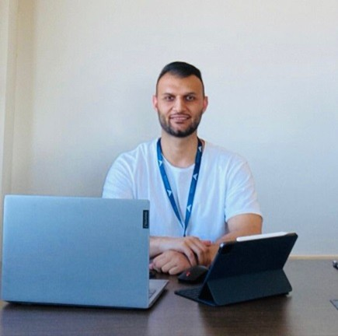

**Feridun AYDINLI**

Education

 Doctorate

* Selcuk University, Institute of Social Sciences, Tourism Management, 2023-continue

 Master

* Selcuk University, Institute of Social Sciences, *Tourism Management*, 2023 (Thesis: Food safety knowledge levels of service personnel working in food and beverage departments in 4 and 5 star hotels: Ankara province example)

 Bachelor

* Selcuk University, Tourism Management, 2019, GPA: 3.26/4

|  |  |  |  |
| --- | --- | --- | --- |
| **Academic Employment** |  | | |
| Research Assistant | College of Tourism | Antalya Bilim University | 2023- |

**Publications**

***Academic Articles***

 Aydınlı, F., Sezgin, M. & Bulut Solak, B., (accepted). Comparison of destination competitiveness ranking in Mediterranean Countries: an analysis of the Travel and Tourism Development Index. *European Journal of Tourism, Hospitality and Recreation*.

 Algan Özkök, G. & Aydınlı, F. (2022). A qualıtatıve study about konya oven kebab and general characterıcts of a regıonal product. *Journal of Gastronomy, Hospitality and Travel, 4*(2), 83-94, <https://doi.org/10.33083/joghat.2022.115>.

 Aydınlı, F., & Bulut Solak, B. (2024). Evaluation of Atatürk Forest Farm Museum and Exhibition Hall in terms of gastronomy museums in Turkey. *Aydın Gastronomy, 8*(1), 43-64. https://doi.org/10.17932/IAU.GASTRONOMY.2017.016/gastronomy_v08i1004.

Aydınlı, F., & Akgöz, E. (2024). Attitudes and motivations towards technology addiction and digital detox tourism: an evaluation by tourism academics. *Journal of Selcuk University Vocational School of Social Sciences, 27*(1), 357-370. <https://doi.org/10.29249/selcuksbmyd.1453630>.



 Aydınlı, F., Gürs, B. & Doğan, O. (2025). Cultural heritage from an interdisciplinary perspective: analysing the perspectives of architecture and tourism academicians*. Journal of Mediterranean Tourism Research, 4*(1), 1-32.

 Temizel, G., Aydınlı, F., & Solak, B. B. (2024). Food waste management in all-inclusive hotels: an exploratory research in Antalya, Türkiye. *Journal of Management and Economic Studies, 6*(3), 245-270. http://doi.org/10.26677/TR1010.2024.1447.

***Proceedings***

 Algan Özkök, G. & Aydınlı, F. (2021). Preliminary study on Konya Furun Kebab. III. International Sustainable Tourism Congress (pp. 449-456). Bingöl University-Ordu University. Bingöl-Ordu.

 Aydınlı, F. & Bulut Solak, B. (2022). Food and beverage operations and safety in hospitality industry during and after the Covid-19 outbreak: The Turkey ccenario. *1st International Congress on Modern Sciences* (pp. 1083-1097). Tashkent Chemical-Technological Institute. Tashkent.

 Aydınlı, F., Bulut Solak, B., Ertaş, M., Avcı, H. & Kurnaz, A. (2023). Investigation on the status of local cheeses of Konya in Gastronomy tourism and the reasons for consumers’ preferences. *International Conference "The Future of Tourism - Innovation and Sustainability" within the IV MILLENIALS' TOURISM FEST.* Management Development Institute of Singapore in Tashkent. Tashkent.

***Book and Book Chapters***

 Bulut Solak, B. Aydınlı, F. & Amin, S. B. (2023). Food and beverage operations and safety: the global scenario. Eds. H. Sezerel, & B. Christiansen, In *Handbook of Research on Sustainable Tourism and Hotel Operations in Global Hypercompetition*, (pp. 451-474). IGI Global. <https://doi.org/10.4018/978-1-6684-4645-4.ch021>.

 Bulut Solak, B. & Aydınlı , F. (2023). Assessing food safety and food waste relatively among food handlers practices in developing countries. Eds. Ş. Aydın, E. Özgül Katlav, K. Çamlıca, & F. Yönet Eren, In *Impactful Technologies Transforming the Food Industry*, (pp. 196-213). IGI Global. <https://doi.org/10.4018/978-1-6684-9094-5.ch013>.

* Aydınlı, F. & Bulut Solak, B. (2023). Service personnel and food safety in hotel businesses. In Ed. O. Çelen, & A. Ünal, in *Tourism and Destination Research-III*. (pp. 233-256), Paradigma Akademi Yayınları, Çanakkale.
* Ünal, C. & Aydınlı, F. (2024). Marketing mix elements: human. Ed. E. Koç, A. Yazıcı Ayyıldız & T. Ayyıldız in Tourism Marketing (pp. 242-270), Detay Publishing, Ankara.

**Projects**

"Food safety knowledge levels of service personnel working in 4 and 5 star hotel establishments: The case of Ankara", Co-executive Director.

**Media Appearances**

**Courses/Teaching**

**Research Interests**

* Big Data
* Data Mining
* Text Mining
* Tourism Marketing
* Destination Competitiveness
* Cultural Heritage and Tourism
* Gastronomy Tourism
* Food Safety
* Food Waste

**Languages**

 Turkish Native