

**ANTALYA BİLİM UNIVERSITY**

INDUSTRIAL ENGINEERING

FACULTY MEMBERS

SHORT BIOS

August 2020

Prof. İSMAİL YÜKSEK

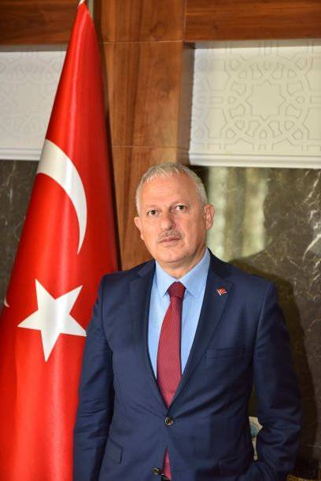

STUDY TOPICS:

* Mechanical Dynamics
* Vibration Optimization

Prof. İsmail Yüksek has been the Rector at Antalya Bilim University since December 22, 2016. He completed his undergraduate education at Yıldız Technical University in 1984 and received his master’s degree in 1987 and Ph.D. in 1995 at the same university. He worked as a research assistant at Yıldız Technical University in 1986-1994, lecturer in 1995-1996, assistant professor in 1996-1999, and associate professor in 1999-2005, and continued his career as a professor from 2005 to 2016. Istanbul Chamber of Industry Consultancy (1999), Vice President of the Turkish Engineers Union (1999-2006), Head of Mechatronics Engineering Department (2007), Mechanical Theory, System Dynamics and Control Department Head (2006-2007), Faculty Board Membership (2007 Vice Dean of Faculty of Mechanical Engineering (2003-2005), Vice President of Mechanical Engineering Department (2003- 2004), Mechanical Faculty Board Member (2004-2006), KOSGEB Consultancy (2004 - 2008), TÜBİTAK-MAKİTEG Field Committee Member (2008-2010) and TÜBİTAK-MAKİTEG referee (2005-2008). Yüksek also served as a member of the Scientific Committee of TÜBİTAK between September 12, 2011 and 2014, and as a Board Member of TÜBİTAK MAM between 2013 and 2016. İsmail Yüksek, who worked in a research project on vehicle vibrations in Milan Polytechnic with the scholarship given by the Italian Government in 1994-1995, had a post-doctoral study at JST, Mechanical Engineering Laboratory with the Japanese Ministry of Industry Scholarship between 1999-2000. İsmail Yüksek, who teaches undergraduate courses titled Machine Dynamics I, Machine Dynamics II, Automatic Control, Computer Aided Drawing and Basic Computer Technologies and Usage, and graduate courses titled Vibration Isolation, System Dynamics and Control, Active Control of Vehicle Vibrations has many national and international publication. Prof. İsmail Yüksek served as the Rector of Yıldız Technical University University between August 2008 and 2016. He is married and has three children.

AssoC. Prof. semail ülgen

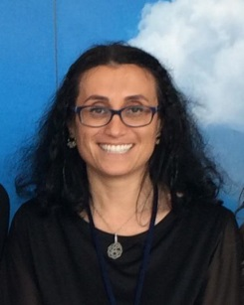

STUDY TOPICS:

* Stochastic Modeling;
* Simulation;
* Finsler Geometry
* Noncommutative Geometry:
* Online Mathematics Education

Assoc. Prof.  Semail Ülgen is the chair of Industrial Engineering Department at Antalya Bilim University where she has been on the faculty since 2012. She received Ph.D. degree in Mathematics at Purdue University in 2005, and B.S. degree at Bilkent University in 1995. In years 2004-2006 she was at University of Mississippi, Oxford, MS as an assistant professor. Then she worked at Grand Valley State University, Allendale, MI, as an assistant professor for one year in 2006 and later she worked as an assistant professor at Northwestern University for three years starting in 2007. She held visiting assistant professor position at Indiana University, Bloomington, IN as an assistant professor for one year in 2011-1012. Dr. Ülgen was a recipient of the Young Scientist Award for Turkish American Scientists and Scholars Association (USA) in 2006. Her research interests are Finsler Geometry; Noncommutative Geometry, Applications to Mathematical Physics. She is also building research interest in stochastic processes and its applications. She was a researcher in TUBITAK 1001 (the Scientific and Technological Research Council of Turkey) research project (#113F311, Title: Einstein metrics in Finsler Geometry) for two years in 2014. She served as the adviser for the Survey Development and Implementation ATSO Pilot Project for Determining the Industrial 4.0 Status of Companies in Antalya in 2017. She was the academic adviser of the TUBITAK Efficiency Challenge Electric Vehicle Competition for mainly engineering undergraduate students during the years 2016, 2017, and 2020 organized by TUBITAK.  Her team built two electric cars (got 25th in the competitions) and attended the competitions.

**Email:** [**sulgen@antalya.edu.tr**](mailto:sulgen@antalya.edu.tr)

AssoC. Prof. HAKAN ŞİMŞEK

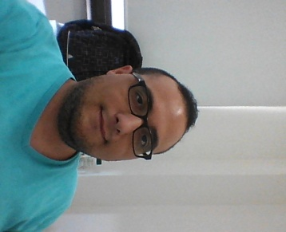

study topıcs:

* Curves and Surfaces Theory
* Riemann and Finsler Manifolds
* Minkowski-Lorentzian Geometry
* Singularity Theory
* Clifford’s Algebras
* Kinematics Geometry and Quaternions Theory
* Fuzzy Logic
* Fuzzy Topology

Hakan Şimşek received his BS degree in mathematics (2008, Akdeniz University), his MS degree in mathematics-fuzzy logic and topology (2010, Akdeniz University), and his PhD degree in mathematics-differential geometry (April, 2016, Akdeniz University). He earned his title of associate professor in geometry in July 2019. He is currently an associate professor in the Department of Industrial Engineering at Antalya Bilim University. Dr. Şimşek is an author and coauthor of 12 journal papers (nine of them are indexed by SCI). His research areas are differential geometry, singularity theory, Riemann and Finsler manifolds, Lorentz geometry, Fuzzy logic and systems, optimization, fuzzy topology, Euclidean and Lorentzian motions, Information Geometry and so on. He was adviser of the Unmanned Aerial Vehicle (UAV) competition-2018 between undergraduate students, organized by the Scientific and Technological Research Council of Turkey (TUBITAK). He was a scholarship PhD student in research project (whose tittle is Einstein metrics in Finsler Geometry) supported by TUBITAK 1001 program. He worked with AGT company on pallet optimization together with 3rd and 4th grade students.

**E-mail:** hakan.simsek@antalya.edu.tr

ASST. PROF. SEVGİ ŞENGÜL AYAN



study topıcs:

* Computational Neuroscience
* Ion channels
* Calcium regulation
* Mathematical Neuroscience
* Dynamical systems analysis
* Mathematical modeling
* Biomathematics
* Biostatistics
* Mathematical & Computational biology
* Applied mathematics
* Ordinary and Partial Differential Equations
* Mathematical and Statistical analysis
* Bioinformatics

Sevgi Şengül Ayan received her BS degree in Mathematics (2005, Dokuz Eylül University), her MS degrees in Mathematics and Computer Science (2010, Western Kentucky University), and her PhD degree in Mathematics/Biomathematics (2014, Florida State University). She is currently an assistant professor in the Department of Industrial Engineering at Antalya Bilim University where she leads research activities in the field of Biomathematics specifically on Computational Neuroscience. Dr. Şengül is an author and coauthor of journal papers with more than 300 citations. She is currently establishing the Computational Neuroscience Laboratory at Antalya Bilim University by TÜBİTAK 3501 and TÜBİTAK 1001 projects. Her research interests include modeling electrically excitable cells including neurons, cardiomyocytes and pancreatic B-cells and dynamical system analysis.

**Email:** sevgi.sengul@antalya.edu.tr

ASST. PROF. Kamer ÖZGÜN



STUDY TOPICS:

* Project Management
* Strategy Planning
* Business Model
* Data Management, Management with Goals
* Brand Management,
* Corporate Performance Tracking,
* Decision Support Systems

Kamer Özgün graduated from Mechanical Engineering, Boğaziçi University, Turkey in 2004. She received her MS degree in 2007 and her Ph.D. degree in 2012 in Industrial Engineering from Boğaziçi University. During her graduate studies, she contributed software development and application studies of ICRON Technologies company which provides Advanced Planning, Scheduling and Optimization Solutions. While she was completing her Ph.D. studies she started to work as Business Development Director for Unique Yacht Design, Antalya, Turkey. She has executed Project Planning, Project Monitoring and Control, Budget Control in various projects in Mega Yacht Sector. She is currently an assistant professor in the Department of Industrial Engineering at Antalya Bilim University. Her main research interest includes intelligent scheduling systems, planning, modeling and optimization with real data and data mining.

**Email:** [**kamer.ozgun@antalya.edu.tr**](mailto:kamer.ozgun@antalya.edu.tr)

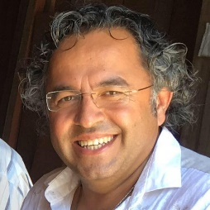

STUDY TOPICS:

* Dijital Transformation Methodology and Framework Design
* Design of Sustainable Ecosystems
* Strategic Planning of ScienceParks and Technoparks.
* Industry 4.0 Assesment
* Blockchain
* Multi-dimensional
* Transformation Methodologies
* Healthcare Innovation Ecosystem
* Strategy and Innovation
* Business Model Design in organisations
* Reinventing business and business model design with a ecosystem approach for sustainability,
* Innovation and Entrepreneurship, Technology Management,
* Management of R&D and Innovation
* Defence and Airborne Technologies
* Information System Design
* Smart and Sustainable City Strategies and Technologies

ASST. PROF. ALİ CEM BAŞARIR

Ali Cem Başarır received his B.S. degree in Electrical and Electronics Engineering from the Military Academy, Ankara, Turkey in 1993. After graduation he started to work in EW and SIGINT Projects and Operations in Defence. While he was working in defence he received his MSc. degree in Information Systems, Informatics Institute, Middle East Technical University, Ankara, Turkey in 2001. He had taken part in NATO Operations in Former Yugoslavia (SFOR), Northern Iraq and Afghanistan (IFOR). After these tough experiences, he earned PhD. degree in Technology Management, Defence Institute, Military Academy in 2009. He contributed and led many large scale defence projects. He retired in 2013 from the Military with two NATO Medals and many awards. He achieved a grant with an innovational business model in Healthcare. He led the founding of a university as founding General Secretary and Rector Adviser in 2013-2016. He was consultant to many organizations in technology management, R & D and Innovation Management fields. He designed an Ecosystem Model for a newly establishing Techno-Park in Antalya. Currently he is now developing models and methodologies for transformation to Industry 4.0 and Digitalization fields for organizations and Defence Industry. He is also consultant to Antalya Chamber of Commerce, Technopark Istanbul and UBM EMEA.

**Email:** alicem.basarir@antalya.edu.tr

Prof. NİMETULLAH BURNAK

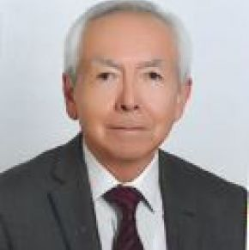

STUDY TOPICS:

* Production and Service Systems
* Statistics
* Total Quality Management

|  |
| --- |
| Nimetullah Burnak is a professor of Industrial Engineering. He received his B. Sc. degree in Mathematics from Middle East Technical University in April 1978, and the Ph. D. degree in Business Management from Anadolu University in 1986. From 1979-1993 he worked as research assistant, assistant professor, and associate professor in Industrial Engineering Department (IE Dept.) at Anadolu University. He conducted his post-doctorate studies at Drexel University, Philadelphia, USA, for six months in 1989. (Eskişehir) Osmangazi University (ESOGU) was established by separating some faculties from Anadolu University at August 1993, and he joined IE Dept. at ESOGU. He was appointed as a professor in IE Dept. at 1996. He worked at ESOGU as department chair, member of university senate, member of board, director of [Institute of Science and Technology](http://fbe.ogu.edu.tr/) and many other boards. He was retired at November 2019 from ESOGU, and joined as part-time faculty member to IE Dept. in Feb. 2020 at Antalya Bilim University. His research interests covers such as statistics, total quality management, production and service systems. He completed many projects at public and private sectors as a team member and/or project director; a few examples are as follows: KORDSA: Statistical Process Control, TEI (Eskişehir) Statistical Techniques-Six Sigma Education, KOSGEB: (Many cities as consultant) Introduction To Quality Assurance Systems-ISO 9000. He consulted many M.Sc. and Ph. D. theses. He teaches undergraduate and gradute courses on statistics, statistical quality control, design of experiment, acceptance sampling, total quality management. He also conducted graduate theses together with graduation students applied to industrial problems in many companies. He is also pursuing new research/application projects on quality related topics, and is willing to share his experience with the students.  **Email**: nimetullah.burnak@antalya.edu.tr |

ASST. PROF. ŞENAY SADIÇ



STUDY TOPICS:

* Operations Research
* Supply Chain Management
* Modelling
* Data Science
* Intelligent Production Systems

Şenay Sadıç received her BSc degree in Management Engineering and her MSc degree in Industrial Engineering from Istanbul Technical University. While doing her MSc studies, she worked as a research and teaching assistant at Istanbul Technical University, Industrial Engineering department. Later, she further obtained her PhD degree in Engineering Design and Advanced Manufacturing from the MIT Portugal program, which is a collaborative program between the Portuguese government and the Massachusetts Institute of Technology, Boston. During her PhD, she also worked as a research scientist at Inesc Porto, Enterprise Systems Modeling/Engineering center and contributed to several projects on manufacturing networks and SME collaboration. Her research interests include supply chain optimization and modeling, innovative business models, data science and smart manufacturing.

**Email:** senay.sadic@antalya.edu.tr

ASST. PROF. FATİH AK



STUDY TOPICS:

* Occupational Safety and Health, Optimization,
* Multi-Criteria Decision Making Methods,
* Fuzzy Systems,
* Neural Networks,
* Ergonomics,
* Forecasting,
* Renewable Energy Resources
* Health Systems

Muhammet Fatih Ak received his Ph.D. degree in industrial engineering occupational health and safety program from Yıldız Technical University (YTU) in 2017. He is currently an assistant professor in the Department of Industrial Engineering and director of the Vocational School at Antalya Bilim University (ABU). He won first place winner award in his bachelor, master and Ph. D programs. He is awarded by TÜBİTAK graduate scholarship. He worked for several years as a research assistant in FMV Işık University and Özyeğin University. He has a “A class” certificate in occupational health and safety. His research interests include occupational safety and health, optimization, multi-criteria decision making methods, fuzzy systems, neural networks, ergonomics, forecasting, renewable energy resources and health systems. He is also pursuing new research projects on smart systems and IoT.

**Email:** fatih.ak@antalya.edu.tr

ALİ ENGİN DORUM, RES. ASST.

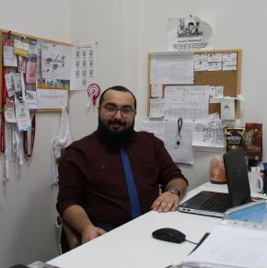

STUDY TOPICS:

* Humanitarian Logistics,
* Combinatorial Optimization,
* Supply Chain Management
* Logistics.

Ali Engin Dorum received his bachelor from Izmir University of Economics on Industrial Systems Engineering. He has continued his studies at Izmir University of Economics with Msc. on Industrial Engineering. He has worked as a Research Assistant for a year during his master and has been working at Antalya Bilim University. He has been working as a Coordinator at Graduate Office and Career Development Coordinatorship since August 2018. He is working on Humanitarian Logistics, Combinatorial Optimization, Supply Chain Management and Logistics.

**Email:** [**engin.dorum@antalya.edu.tr**](mailto:engin.dorum@antalya.edu.tr)

CANSU ALTAN KOYUNCU, RES. ASST.

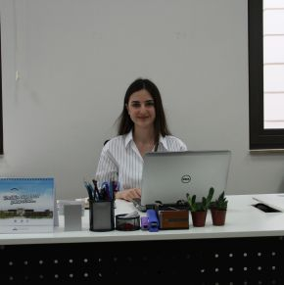

STUDY TOPICS:

* Digital Transformation ,Industry 4.0
* Multiple Criteria Decision Making
* Optimization

Cansu Altan Koyuncu received her BSc degree in Industrial Engineering from Süleyman Demirel University (2012) and MSc degree in Industrial Engineering from Süleyman Demirel University (2019). She started her PhD at Eskişehir Osmangazi University in 2019, still continues. After the BSc, she worked as a purchasing specialist at Göltaş A.Ş and as a project coordinator at Sunrise Yatching. After working as project coordinator at Sunrise Yatching in 2016, she started as a Research Assistant at Antalya Bilim University and still continues. She works in the fields of Industry 4.0 and multiple criteria decision making.

**Email**: [cansu.altan@antalya.edu.tr](mailto:cansu.altan@antalya.edu.tr)

Mustafa Said YURTYAPAN, RES. ASST.

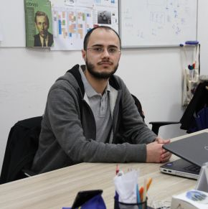

STUDY TOPICS:

* Multiple Criteria Decision Making
* Optimization

Mustafa Said YURTYAPANreceived his BSc degree in Industrial Engineering from Atatürk University (2014) and MSc degree in Industrial Engineering from Süleyman Demirel University (2019). He started as a Research Assistant at Antalya Bilim University in 2017 and still continues. He works in the fields of optimization and multiple criteria decision making.

**Email:** said.yurtyapan@antalya.edu.tr

ÜMRAN KAYA, RES. ASST.

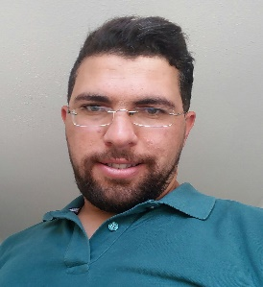

STUDY TOPICS:

* Simulation
* Optimization

Ümran KAYAreceived his BSc degree in Industrial Engineering from Gaziantep University (2012) and MSc degree in Industrial Engineering from Süleyman Demirel University (2019). He started his PhD at Gazi University in 2019, still continues. After the BSc, he worked as a production planning engineer at Şölen Çikolata A.Ş. After working as a production engineer in Erzurum Metropolitan Municipality in 2017, he started as a Research Assistant at Antalya Bilim University and still continues. He works in the fields of simulation and optimization.

**Email:** [**umran.kaya@antalya.edu.tr**](mailto:umran.kaya@antalya.edu.tr)

HATİCE ERDOĞAN AKBULUT, RES. ASST.

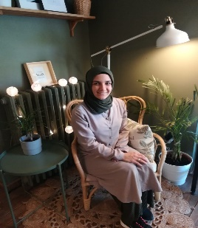

STUDY TOPICS:

* Scheduling
* Optimization

Hatice ERDOĞAN AKBULUTreceived her BSc degree in Industrial Engineering from Gazi University (2016). She started her MSc at Eskişehir Osmangazi University in 2017, still continues. In November 2017, she started as a research assistant in the Department of Industrial Engineering at Antalya Bilim University and still continues. Her research interests include scheduling and optimization.

**Email:** [**hatice.erdogan@antalya.edu.tr**](mailto:hatice.erdogan@antalya.edu.tr)