GER 301 SYLLABUS

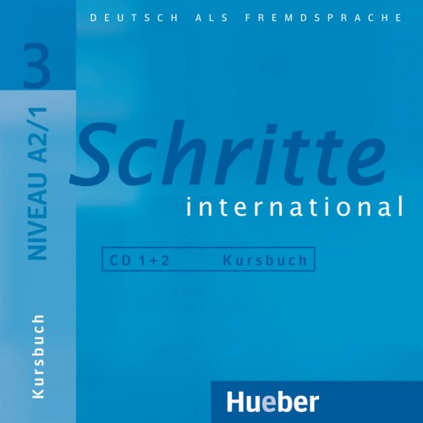
Credits: 5
ECTS: 5
Attandance: % 20

Books: Schritte International A2/1
Kursbuch+Arbeitsbuch
Hueber
ISNB 978-3-19-001853-6

IMPORTANT NOTE: Books and dictionary are mandatory. Books can not be photocopied, original books will be accepted in order to respect copyright.
Additional Material:
- Grammatik Intensivtrainer
Langenscheidt ISNB 978-3-12-606359-3
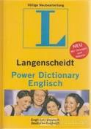
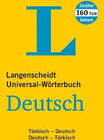
2.Dictionary

ABOUT THIS SYLLABUS
THIS IS IMPORTANT: This syllabus is essential for you to follow the requirements of the course. You should bring your syllabus to all the classes. It is your responsibility to follow the requirements, deadlines and assignments of the course, and all of these are included in this syllabus. Answers to all your questions regarding this class are in this syllabus. Therefore, please do not consider this syllabus something that you see on the first meeting and put somewhere deep in your bookshelf. Do not forget that this is an essential material for this course.
COURSE DESCRIPTION
A2 Elementary use of language
The Goethe-Zertifikat A2 is a German exam for adults. It requires elementary language skills and corresponds to the second level (A2) on the six-level scale of competence laid down in the Common European Framework of Reference for Languages (CEFR).
OUR LEARNING CONCEPT
Our tuition
- reflects the most recent knowledge in teaching and learning research.
- is varied and communicative. Speaking, listening, reading and writing are practised in situations based on real-life, using authentic texts.
- is oriented to topical and inter-cultural subject matter. Themes based on regional culture, projects and research tasks provide a variety of opportunities to approach the subject of German-speaking culture.
- The teaching language is German right from the first lesson.
OUR COURSE SYSTEM
- is based on the six levels defined in the Common European Framework of Reference for Languages. This means that the language skills you acquire in our courses can be measured objectively and are internationally comparable.
- is standardised and transparent.

THE EXAM SECTIONS
The Goethe-Zertifikat A2 exam comprises reading, listening, writing and speaking sections.
The exam is administered and evaluated in the same way all over the world.
Reading
You will be asked to read texts such as short newspaper articles, emails, advertisements and public announcement boards and then complete exercises about what you have read.
Duration: 30 minutes
Writing
You will be asked to write messages related to your everyday environment.
Duration: 30 minutes
Listening
You will be asked to listen to everyday conversations, announcements and interviews on the radio, messages on the telephone and public announcements and complete exercises about what you have heard.
Duration: 30 minutes
Speaking
You will be asked to pose and answer questions in conversations about yourself, converse about your own life and make agreements or negotiate with your conversation partner.
Duration: 15 minutes
REQUIREMENTS
The Goethe-Zertifikat A2 is a German exam for adults.
The Goethe-Institut exams are available to all interested parties and can be taken regardless of age and nationality. —A minimum age of 16 years is recommended to take the Goethe-Zertifikat A2 exam.
—To sit the Goethe-Zertifikat A2: Start Deutsch 2 exam, candidates must have German language skills corresponding to the second level of competence (A2) of the Common European Framework of Reference for Languages (CEFR).
—To reach this level, candidates should have completed between 200 and 350 45-minute classes, depending on their previous knowledge and learning requirements.

GERMAN EXAMINATIONS
- German exams are internationally recognized and are accepted as proof of qualification by many employers and educational establishments.
- All exams for adult learners at the Goethe-Institut are audited by the Association of Language Testers in Europe (ALTE) and have been awarded the Q-Mark quality seal.

Passing the exam demonstrates that you can ...
—understand and use sentences and common expressions in everyday situations,
—make yourself understood in simple, routine situations demanding an exchange of information on familiar and common topics,
—describe your background and education, immediate surroundings and other matters associated with your immediate needs in a simple way

COURSE POLICIES
• ANNOUNCEMENT POLICY: All information regarding the course will either be announced in class or be sent to your ABU e-mail address. Check your e-mail regularly. It is your responsibility to beware the information announced through e-mail.

• ATTENDANCE POLICY: Attendance is mandatory and will be taken at each class. If you miss 6 classes (20%) you will fail the class. Students who are late more than 15 minutes are not admitted to the classroom. If you come late 2 times, you will be counted as missing a whole class.
• CLASSROOM CONDUCT: In the classroom and you will be expected to act according to the rules of class conduct and courtesy. Any form of hate speech and disruptive behavior are not welcome and tolerated.
• MOBILE PHONE POLICY: Make sure that your mobile phones are switched off during class time.
• MAKE-UP POLICY: Requests for midterm exam make-ups will be considered only for students with a medical condition (Written report or email by the Secretary of the Faculty). If an emergency arises, student needs to contact me before or immediately after the midterm exam.

ACADEMIC HONESTY
There will be zero-tolerance to any form of academic dishonesty. Plagiarism, cheating during exams and any other attempt of academic dishonesty will result in disciplinary action. Please see the Departmental Student Handbook for specific information about academic honesty and plagiarism. Students are responsible for making sure that their assignments do not contain any form of academic dishonesty. Please consult the instructor for situations that you are not certain about your references in your assignments.
EVALUATION
- Midterm Exam: 30%
- Quiz: %10
- Homework: %10
- Final Exam: 50%

GRADING SCALE: This grading scale is developed by the faculty members of Department of Political Science and International Relations. This course will follow this grading scale.
A | A- | B+ | B | B- | C+ | C | C- | D+ | D | F
95-100 | 85-94 | 80-84 | 75-79 | 65-74 | 60-64 | 55-59 | 50-54 | 45-49 | 40-44 | 0-39

COURSE SCHEDULE

Week 1: Introduction and Syllabus
Week 2: Introduction
Week 3: At home
Week 4: At home
Week 5: Good Appetite
Week 6: Good Appetite
Week 7: Working world
Week 8: Working world
Week 9: Sports und fitness -Midterm
Week 10: Sports und fitness
Week 11: Education and career
Week 12: Education and career
Week 13: Solid and gifts
Week 14: Solid and gifts

Links
Summer Language Courses in Germany
- http://www.daad.de/deutschland/deutsch-lernen/sommerkurse/00490.de.html
- Munich International Summer University http://www.ssk-misu.de/content/EN/
- http://www.iik-duesseldorf.de/deutschkurse/sommerkurse-berlin.php
- http://www.iik-duesseldorf.de/deutschkurse/sommerkurse.php
Praktikum in Germany
- http://www.s-a.uni-muenchen.de/studierende/jobboerse/praktika_inland/index.html
- http://www.praktikum-service.de/Praktika_Index.php
Online Exercises
- http://www.iik.com/uebungen/
- mein-deutschbuch.de
- nthuleen.de
- goethe.de
- schubertverlag.de
- Dictionary
- (English-German) http://dict.leo.org/
Online Placement Test
- http://www.goethe.de/cgi-bin/einstufungstest/einstufungstest.pl
Exams
- (Türkisch) http://www.goethe.de/ins/tr/ist/lrn/prf/trindex.htm
- Zertifikat Deutsch, Übungssatz 0.4 Download http://www.goethe.de/mmo/priv/1740559-STANDARD.pdf
- Goethe-Zertifikat C 1 (in the past ZMP) http://www.goethe.de/ins/tr/ist/lrn/prf/c1/deindex.htm
- ZOP (berechtigt zur Aufnahme eines Studiums in Deutschland, befreit von der DSH-Prüfung) http://www.goethe.de/ins/de/prf/zop/enindex.htm
News (Newspapers, Television)
- Zweites Deutsches Fernsehen http://www.zdf.de/ZDFde/inhalt/20/0,1872,5248820,00.html
- Deutsche Welle http://www.deutsche-welle.de/dw/0,2142,265,00.html
- ZDF Nachrichten http://www.heute.de
- Spiegel-Online http://www.spiegel.de
- Focus http://www.focus.de
- Tagesspieglel http://www.tagesspiegel.de
Institutions
- Home DAAD German Academic Exchange Service http://www.daad.de/de/index.html
- DAAD Information Center Istanbul http://www.daad-istanbul.com
- Home Goethe-Institute Istanbul http://www.goethe.de/ins/tr/ist/deindex.htm
Common European Framework of Reference for Languages
- http://www.linguanet-europa.org/pdfs/global-scale-grid-en.pdf
http://www.coe.int/T/DG4/Linguistic/CADRE_EN.asp#TopOfPage

