Open Office Etiquette

- Stay quiet (talking & laughing quietly, listening to music with headphones etc.)
- Keep your space clean
- Respect privacy
- Be tolerant
- Keep your cellphones on silent mode
- Be aware of smells (lunch, perfume etc.)
- Think like a team
- Keep visits short
- Avoid the urge to gossip
- Be positive and
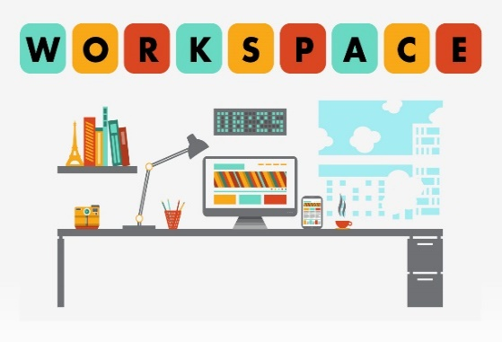
Form No: KD-FR-0010 Yayın Tarihi:05.03.2020 Değ.No:0 Değ. Tarihi:-

