INFORMATION ABOUT IFS ONLINE INTERNSHIP SYSTEM and INTERNSHIP PROCEDURES
Dear Students,
As of the 2020-Spring period, the online system has been switched to the internship procedures of the Faculty of Engineering. The internship directive has also been updated as of 2020-June and the Industrial Engineering internship work flow document has been recreated. This document has been prepared to explain how to use the online internship system IFS ( https:// IFS .antalya.edu.tr ) and to answer your questions.
It is accepted that all of our students know the Internship Directive of the Faculty of Engineering, the Internship Workflow and the information presented here ( https://ubs.antalya.edu.tr - instructions).

What are the preparations to be made before the internship?
The student who will do the internship is responsible for finding the internship place, informing the internship commission head in the department or the department internship officer and presenting the necessary information for the start of the internship.

How are Internship Registration Procedures Made?
In order to register for the internship, the student's " EM-FR-0006 Internship " link ( https://antalya.edu.tr/tr/fakulte-ve-enstituler/bolumler/endustri-muhendisligi/icerik/staj-2/formlar-4 ) Information and Consent It is necessary to fill the form ” and send an e-mail to the address “ 2020iestaj@antalya.edu.tr ”.

In order to register for the internship, the student must fill out the form “EM-FR-0006 Staj Bilgi ve Onay Formu” in the link (https://antalya.edu.tr/tr/fakulte-ve-enstituler/bolumler/endustri-muhendisligi/icerik/staj-2/formlar-4) and send an e-mail to the address “2020iestaj@antalya.edu.tr”.
After the student submits the information requested above, the internship record in the IFS system is created by the department internship supervisor. After the internship record is created in the IFS system , the system automatically sends an e- mail to the internship place manager and informs the human resources of the university for SSI entry.
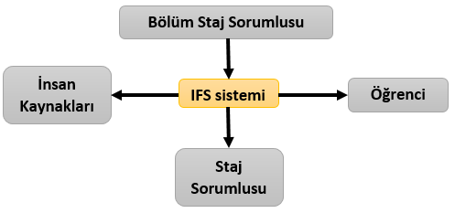
The system sends the information to the internship supervisor where he can log into the system. This e-mail means that the internship has been approved by the department . It is not necessary for the university to give any document -except the SGK entrance certificate- to the internship place.

What Should Be Done During the Internship Process?
After the internship starts, the student can enter the IFS system with their user information. If the student is entering the system for the first time, the student number is both the user name and the password . The student can then change their password. The student fills in 4 weekly internship reports through the IFS system and completes the internship.

What should be done after the internship?
The student must fill in the 4-week internship report from the IFS system within 2 weeks at the latest after the internship ends and have the internship approved by the internship location manager. After the internship place manager approves the internship; The internship will be evaluated by the department.
Staj, Bölüm Tarafından Değerlendirmeye Alınır.
Staj Yeri Sorumlusu, Tamamlanmış Raporu IFS Üzerinden Değerlendirir.
Öğrenci IFS’den Staj Raporunu Doldurur

This document has been prepared by the Industrial Engineering Department Internship Committee Members . For your questions, you can contact the Industrial Engineering Department Internship Committee Members. (Contact information of the commission members is given below.)

How can I reach the Internship Committee Members of the Department of Industrial Engineering?

2022 EM Internship < 2020iestaj@antalya.edu.tr >

