T.C.
ANTALYA BILIM UNIVERSITY
INSTITUTE OF POSTGRADE EDUCATION

!!! THE PROGRAM WHERE THE THESIS IS DONE !!!

!!! MASTER'S THESIS/ DOCTORAL THESIS/ SEMESTER PROJECT!!!

!!! WRITE THE THESIS TITLE HERE BY CENTERING……..
IT IS RECOMMENDED TO SELECT THE TITLE WITHOUT EXCEEDING THREE LINES.!!!

!!! Name SURNAME !!!

!!! JUNE 2022 !!!

ANTALYA

T.C.
ANTALYA BILIM UNIVERSITY
INSTITUTE OF POSTGRADE EDUCATION

!!! THE PROGRAM WHERE THE THESIS IS DONE !!!

!!! MASTER'S THESIS/ DOCTORAL THESIS/ SEMESTER PROJECT!!!

!!! WRITE THE THESIS TITLE HERE BY CENTERING……..
IT IS RECOMMENDED TO SELECT THE TITLE WITHOUT EXCEEDING THREE LINES.!!!

!!! Name SURNAME !!!

!!! JUNE 2022 !!!

ANTALYA

T.C.
ANTALYA BILIM UNIVERSITY
INSTITUTE OF POSTGRADE EDUCATION

!!! WRITE THE THESIS TITLE HERE BY CENTERING……..
IT IS RECOMMENDED TO SELECT THE TITLE WITHOUT EXCEEDING THREE LINES.!!!

!!! Name SURNAME !!!

This study was supported by!!! THE GRANT ORGANIZATION!!! Grant No: !!!….!!!.

T.C.
ANTALYA BILIM UNIVERSITY
INSTITUTE OF POSTGRADE EDUCATION

!!! WRITE THE THESIS TITLE HERE BY CENTERING……..
IT IS RECOMMENDED TO SELECT THE TITLE WITHOUT EXCEEDING THREE LINES.!!!

!!! Name SURNAME !!!

This thesis was accepted by the jury (with unanimous vote / majority vote) on the date !!!…./….../202….!!! in !!! THE PROGRAM WHERE THE THESIS IS DONE!!! of !!! THE DEPARTMENT WHERE THE THESIS IS DONE!!!

!!! Title Name SURNAME!!! (Supervisor) [signature]

!!! Title Name SURNAME!!! [signature]

!!! Title Name SURNAME!!! [signature]

!!! Title Name SURNAME!!! [signature]

!!! Title Name SURNAME!!! [signature]

Director of The Institute
!!! Title Name SURNAME!!! [signature]
Thesis Submission Date: !!!…./….../202….!!!

DECLARATION
!!!Ph.D. Thesis / Msc Thesis / Semester Project!!! of this study named “………………..”, which I presented, I declare that scientific moral principles were followed in the preparation of this study, in case of benefiting from the works of others, reference is made in accordance with scientific norms, no falsification has been made in the data used, and that any part of this study is not presented as another academic study.
... / ... / 20..
[signature]
!!! Student Name SURNAME!!!

CONTENTS
ABSTRACT i
ÖZET ii
SYMBOLS AND ABBREVIATIONS iii
LIST OF TABLES iv
LIST OF FIGURES v
PREFACE vi
1. INTRODUCTION 1
1.1. Only Initials of Subtitles are Capital and Bold 1
1.1.1. Third Degree Subsection Headings are Same as Second Degree 1
2. LITERATURE REVIEW 2
2.1. Citing Sources (Citiation) 2
2.2. Footnotes 2
3. METHOD 3
4. FINDINGS 4
4.1. Figures 4
4.2. Tables 7
5. ARGUMENT 8
6. CONCLUSIONS AND SUGGESTIONS 9
REFERENCES 10
APPENDIX 1. CITATIONS IN THE TEXT 12
APPENDIX 2. EXAMPLES OF REFERENCING 13

ABSTRACT
!!! WRITE THE THESIS TITLE HERE BY CENTERING & TITLE SHOULD NOT EXCEED THREE LINES .!!!

!!!Name SURNAME!!!
MSc / PhD Thesis in ….
Supervisor: !!!Title Name SURNAME!!!
!!!August 2022; ---- pages!!!
The abstract is the first part to read in the thesis. Here, information should be given about the purpose of the subject and the materials and methods used, based on what has been done so far in this field. Experiments and studies should be summarized, and the results should be stated.
A well-written abstract should be able to inform the researcher whether the information the researcher is looking for is in this study or not, without reading the entire thesis. In addition, it should be aimed to get an idea about the scope of the study as well as the subject of the study in a short period of time. Accordingly, the researcher should be able to make the decision to examine the thesis in general at this stage. However, unnecessary details should be avoided. For the abstract, averagely, between one page to one and a half page of descriptive information will be appropriate. It should be minimum 150 words.
KEYWORDS: First keyword, Second keyword, !!!!! THE KEYWORDS SHOULD BE IN ALPHABETICAL ORDER!!!! and MINIMUM 4 KEYWORDS.
COMMITTEE: !!!Title Name SURNAME!!!
!!! Title Name SURNAME!!!
!!! Title Name SURNAME!!!
!!! Title Name SURNAME!!!
!!! Title Name SURNAME!!!

ÖZET
!!! TEZ BAŞLIĞINI BURAYA ORTALAYARAK YAZINIZ ÜÇ SATIRI GEÇMEYECEK ŞEKİLDE BAŞLIK SEÇİLMESİ ÖNERİLİR
.!!!
!!!İsim SOYİSİM!!!
Yüksek Lisans / Doktora Tezi, ……….. Anabilim Dalı
Danışman: !!!Unvan İsim SOYİSİM!!!
!!!Ağustos 2022; --- sayfa!!!
Özet kısmı tezin ilk etapta okunan kısmıdır. Burada konunun amacı ve bu alanda şimdiye kadar yapılan çalışmaların kısaca neler olduğundan yola çıkılarak kullanılan materyal ve metot hakkında bilgi verilmelidir. Yapılan deneyler ve çalışmalardan özet olarak bahis edilerek ulaşılan sonuçlar belirtilmelidir.
İyi yazılmış bir özet, araştırma yapan kişinin aradığı bilgilerin bu çalışma içerisinde olup olmadığının bilgisini tezin tümünü okumadan araştırmacıya verebilmelidir. Ayrıca çalışmanın konusu yanı sıra kapsamı hakkında da kısa sürede fikir edinilmesine yönelik olmalıdır. Buna bağlı olarak araştırmacı, tezin genelini inceleme kararını bu aşamada verebilmelidir. Özetin hazırlanmasında kısa ve öz cümlelerle tez hakkında ve elde edilen sonuçlar yönünden aydınlatıcı bilgiler bulunmalıdır. Bununla birlikte gereksiz detaya girmekten kaçınılmalıdır. Özet kısmı için ortalama olarak yarım sayfa ile bir buçuk sayfa arasında bir açıklayıcı bilgi uygun olacaktır. En az 150 kelime olmalıdır.
ANAHTAR KELİMELER: Birinci anahtar kelime, İkinci anahtar kelime, !!!!! ALFABETİK SIRALI OLMALIDIR!!!! ve EN AZ 4 ADET OLMALIDIR.
JÜRİ: !!! Unvan İsim SOYİSİM!!!
!!! Unvan İsim SOYİSİM!!!
!!! Unvan İsim SOYİSİM!!!
!!! Unvan İsim SOYİSİM!!!
!!! Unvan İsim SOYİSİM!!!

SYMBOLS AND ABBREVIATIONS
Symbols

A : First letter of the alphabet (Tab key is pressed after the symbol)
B : Second letter of the alphabet

AS MANY LINES AS REQUIRED CAN BE ADDED HERE.
The notation, symbols and abbreviations used in the thesis should be consistent and the SI (System International) (http://www.ume.tubitak.gov.tr/tr/si-birimleri) standard should be used for units.
If decimal notation is used in the thesis, it should be stated which decimal separator (“21.01” or “21,01”) is used.
Abbreviations
ABU : Antalya Bilim University

LIST OF TABLES
Table 2.1. The first table under the heading of main chapter number two 4
Table 2.2. The second table under the heading of main chapter number two 5

AS MANY LINES AS REQUIRED CAN BE ADDED HERE.
ATTENTION !!!!!!!! to the alignments
Table 2.1. Should be written in bold. !!!!!!!!ATTENTION!!!!!!!!

LIST OF FIGURES
Figure 2.1. The first figure under the heading of main chapter number two 2
Figure 2.2. The second figure under the heading of main chapter number two 3

AS MANY LINES AS REQUIRED CAN BE ADDED HERE.
ATTENTION !!!!!!!! to the alignments
Figure 2.1. Should be written in bold. !!!!!!!!ATTENTION!!!!!!!!

Figures include graphs, maps, diagrams, plans, photographs, etc. except tables. If there are many types of figures, like graphics, diagrams, photos, maps, etc, each group can be numbered separately. For example, if a graphic is used, "Graph 3.1" can be said instead of "Figure 3.1". In this case, a list of preferred expressions should be placed at the front of the research.
If available, LIST OF MAPS, LIST OF GRAPHICS, or LIST OF PICTURES are written with their own headings, each starting from the new page (the "Insert Page Break" function can be used in the Word file). Tables, maps, graphics, figures, or pictures are placed one under the other in numerical order. It is indicated in alignment with the title or content and the page number where it is located.

PREFACE
The preface is the part where the person who made the work can convey his feelings and thoughts to the readers independently of the work before any work is read.
Here, it can be stated why this subject was chosen, the importance of the field, the conditions in which they were doing the study, the events that they thought might be interesting for the readers, and the subjects that they experienced while doing the study. Suggestions may be included in case the work is later developed by others.
During the preparation of the thesis, people and institutions/organizations that provided help can be thanked by creating a paragraph in the preface.

1. INTRODUCTION
In the introduction, which is the first and one of the important parts of the thesis's text, under the "1. INTRODUCTION" title, the reader can be informed about the purpose and scope of the research and the research method after giving the reader the preliminary information about the subject. It can be summarized briefly what will be explained in the sections of the thesis/project.
After the introduction, there are thesis sections. In the thesis sections, the findings and explanations obtained in the research are presented at the required level of detail and in a logical flow that will lead to the conclusion of the thesis. At least two sections should be created between the introduction and the conclusion.
THE SECTION TITLES IN THIS TEMPLATE CAN BE CHANGED BY THE AUTHOR IN APPROPRIATE TO THE SUBJECT. Section numbers should continue in order (starting from 2 with normal numbers).

All FIRST DEGREE headings in the text should be written in bold, 12 font size, must be written in ALL CAPS and centered on the page (and, with, either, or, else, and the question suffix are capitalized.)

1.1. Only Initials of Subtitles are Capital and Bold

1.1.1. Third Degree Subsection Headings are Same as Second Degree
In the Second, Third and (if used) Fourth Degree subsection headings, the FIRST LETTER OF EACH WORD should be written in CAPITAL, the others should be written in lower case. In secondary titles if "and/or/with" etc. If there are conjunctions such as, they should be written in all lowercase letters, if they are to be used, ABBREVIATIONS MUST BE WRITTEN IN THE ORIGINAL CONDITION.
AS MANY LINES AS REQUIRED CAN BE ADDED HERE.

2. LITERATURE REVIEW
The theoretical information on which the thesis is based and the previous publications that are desired to be mentioned in relation to the thesis subject are given in this section by being associated with the topics discussed in the thesis.
THE SECTION TITLES IN THIS TEMPLATE CAN BE CHANGED BY THE AUTHOR IN APPROPRIATE TO THE SUBJECT. For instance, the literature review can take place in the introduction section.

2.1. Citing Sources (Citiation)
Every reference (cited) given in the text of the thesis must be included in the REFERENCES section of the thesis. (For examples, see APPENDIX 1 and APPENDIX 2).

2.2. Footnotes
If written in the text, very short and concise explanations that will distract the subject and prevent continuity while reading can be given in a few lines as a FOOTNOTE at the bottom of the same page on any page of the thesis. After leaving two spaces after the main text on the page, footnotes should be separated by a short line drawn from left to right to the middle of the page. The 3 cm gap that should be left at the bottom edge of the page should never be exceeded. (See footnote at the bottom of the page.)
AS MANY LINES AS REQUIRED CAN BE ADDED HERE.

3. METHOD
In the method section of the thesis, information about the materials and method of the thesis is given.
Theorem 3.1. xxxxxxxxxx
Theorem 3.2. xxxxxxxxxx
$$f\left(x\right)=a_{0}+\sum_{n=1}^{∞}{\left(a_{n}\cos{\frac{nπx}{L}}+b_{n}\sin{\frac{nπx}{L}}\right)}$$ | (3.1)
THE SECTION TITLES IN THIS TEMPLATE CAN BE CHANGED BY THE AUTHOR IN APPROPRIATE TO THE SUBJECT.

4. FINDINGS
The findings obtained from the thesis study should be presented in this section concisely and clearly.

4.1. Figures
Figures should be placed left-aligned on the thesis pages. The description of the figure should also be left-aligned and aligned in the same way as the figure's boundaries. There should be 1 (one) line space between the figure and its description.

Figure 4.1. a) Xxxxxxxxxxxxxx xxxxxx xxxxxxxx xxxxxx xxxxxxx xx xx; b) Xxxxxxx xxx xxxxxxx xxxxx xxx xxxxxxxxx xxxxxxxx xxxxx xxxx xxx. The figure title should be below the figure and the figure number (and... a, b, c...) should be written in bold (also there should be semicolons between the a, b, and c descriptions) (***punctuations should not be placed at the end of the descriptions of the figure***)
*** A LINE SHOULD BE LEFT AFTER THE FIGURES ***
To CITE figures in the text, “As seen in Figure 4.1a…. As seen in Figure 4.1.b…” formats are used.

Figure 4.2. a) Xxxxxxxxxxxxxx xxxxxx xxxxxxxx xxxxxx xxxxxxx xx xx; b) Xxxxxxx xxx xxxxxxx xxxxx xxx xxxxxxxxx xxxxxxxx xxxxx xxxx xxx. The figure title should be below the figure and the figure number (and... a, b, c...) should be written in bold (also there should be semicolons between the a, b, and c descriptions) (***punctuations should not be placed at the end of the descriptions of the figure***)
*** A LINE SHOULD BE LEFT AFTER THE FIGURES ***

Table 4.1. Analysis results (Table title should be above the table and the table number should be written in bold. Punctuation should not be placed at the end of the explanations of the table.)
Column A | Column B | Column C | Column D | Column E | Column F | Column G
1.2 | 1.2 | 1.2 | 1.2 | 1.2 | 1.2 | 1.2
2.1 | 2.1 | 2.1 | 2.1 | 2.1 | 2.1 | 2.1
3.5 | 3.5 | 3.5 | 3.5 | 3.5 | 3.5 | 3.5

4.2. Tables
Tables should be placed left-aligned on the page. The description of the tables should also be left-aligned and aligned with the boundaries of the table.
Table 4.2. Xx xxx xxx xxxx xxxxx xxxxxxxxx xxxxxxxxx xxxxxxx xxxxxx xxxxxxx Xxxxxxxx. The table's title should appear above the table, and the table number should be written in bold (*** punctuation should not appear at the end of the table's explanation***).
Column A | Column B | Column C | Column D
1.2 | 1.2 | 1.2 | 1.2
2.1 | 2.1 | 2.1 | 2.1
3.5 | 3.5 | 3.5 | 3.5
*** A LINE SHOULD BE LEFT AFTER THE TABLES ***

In the thesis writing, the decimal part of the numbers should be seperated with a dot/comma as seen in Table 4.2.
Formulas are given in parentheses to indicate the main topic and the numbered formula under that heading. Numbering should be done for each relation deemed necessary. Formula sizes should be chosen to be compatible with 12 points. In the following part, what the symbols used in the formulas mean should be explained. The spelling of the formulas or relations should be like (4.1) given as an example.
$$x=\frac{-b±\sqrt{b^{2}-4ac}}{2a}$$ | (4.1)
There should be 1 (one) line spacing between the equation and the previous and next line. The equation number should be written on the right side of the page, aligned with the previous and next line.

5. ARGUMENT
The place of the findings obtained from the thesis study in the literature is compared and discussed with previous studies and findings, and this section consists of at least three pages. According to the qualifications of the thesis subject and rules of the relevant department, "FINDINGS AND ARGUMENT" can also be presented under a single section.
AS MANY LINES AS REQUIRED CAN BE ADDED HERE.

6. CONCLUSIONS AND SUGGESTIONS
In this section, there should be at least one page stating the conclusions obtained from this thesis, the contributions that it has made or can make to the basic and applied aspects of the relevant discipline, and suggestions that can be made based on the findings of this study.
AS MANY LINES AS REQUIRED CAN BE ADDED HERE.

REFERENCES
!!! TIMES NEW ROMAN 12 POINT FONT IS USED IN THE REFERENCES. THE PARAGRAPH STYLE MUST BE SET TO 0 NC FIRST, AND THEN 6 NC AND SINGLE LINE SPACING (The indent here is 1.25 cm) !!!
(Single-author article in periodicals)
Author's surname, Initial letter of the author's name. (Year). Title of the article. Title of the Periodical, Volume (Number of the Periodical), Page range. http://doi.org/xx.xxxxxxxxxx
(Two-author article in periodicals)
First author's surname, Initials. and Second author's surname, Initials. (Year). Title of the article. Title of the Periodical, Volume(Number of the Periodical), Page range. http://doi.org/xx.xxxxxxxxxx
(Articles with 21 or more authors in periodicals)
First 19 Author's Surname, First letter of authors name, respectively.,. . . Last author's surname, Initials. (Year). Title of the article. Title of the Periodical, Volume(Number of the Periodical), Page range. http://doi.org/xx.xxxxxxxxxx
(Single author book)
Author's surname, Author's initials. (Year). Title of the book (Printing Number). Publisher.
(Book by two authors)
Author's surname, Author's initials. and Author's surname, Author's initials. (Year). Title of the book (Printing Number). Publisher
(Book section)
Author's surname, Author's initials. and Author's surname, Author's initials. (Year). The name of the book chapter. The title of the book is (Printing number, Page range) in it. Publisher
(Theses)
Author's surname, Author's initials. (Year). Title of the thesis [Unpublished master's thesis / Unpublished doctoral thesis]. Name of the university.
Author's surname, Author's initials. (Year). Title of the thesis [Master's thesis / PhD thesis, Name of the University]. Published database/Internet address.
(Scientific Meeting and Symposium)
Meeting and symposium papers can be published in book or periodical format. The book or book chapter format is used when citing the papers published in the book. Periodical publication format is used when citing regularly published papers. The following formats are used for papers/poster presentations or contributions to the symposium that have not been officially published:
Author's surname, Author's initials. (Year, Day, Month). The name of the oral presentation is [Oral Presentation]. Name of Scientific Meeting, City where the Meeting took place, Country.
Author's surname, Author's initials. (Year, month). The name of the poster presentation [Poster presentation]. Name of Scientific Meeting, City where the Meeting took place, Country.
(Unpublished Works)
Author's surname, Author's initials. (Year). Title of article [state of text]. The name of the department where the study was produced, the name of the University.
Author's surname, Author's initials. (in print). The title of the article. The name of the journal to be published.
(Website Resources)
Author Surname, Author's initials or Group name. (Year). Title of the study. The name of the website. Retrieved from the URL on .....
!!!! The sources used in the thesis MUST BE ORDERED ALPHABETICALLY ACCORDING TO THE SURNAME OF THE FIRST AUTHOR. (If you are working on an MS Word file, you can use the A to Z sorting function in the "Home" tab.)
The publications of the same author(s) in different years should be given in chronological order. The publications of the same author(s) in the same year should be designated as a, b, c.. immediately following the publication year.
References are also not given a sequence number, and no itemization is made. The title of the author is not used in the sources; the page numbers are not indicated. !!!!!

APPENDIX 1. CITATIONS IN THE TEXT
Hacettepe University Open Course Materials (2020). APA 7 Academic Publication Principles. Retrieved from. http://acikders.hacettepe.edu.tr/dersler/edebiyat_fakultesi/APA/APA.html on 16.August.2022.
Number of authors included in in-text citations
- For studies with one or two authors, author names are included in each citation. e.g. "Conger and Conger 1990"
- In studies with three or more authors, the first author + et al. (abbreviated in English as "et al.")
- In parenthetical citations, "and" is used between the names of the authors in studies with two authors ("&" in English texts), "and" is used between the author names in narrative quotations.
- The word "and" is used between the names of the authors in tables and figures, both in parentheses and in narrative quotations.
Table APPENDIX 1.1. Citation in the text (Turkish example)*
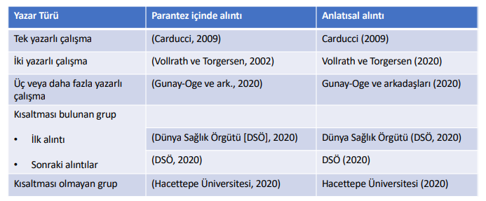
Table APPENDIX 1.2. Citation in the text (English example)
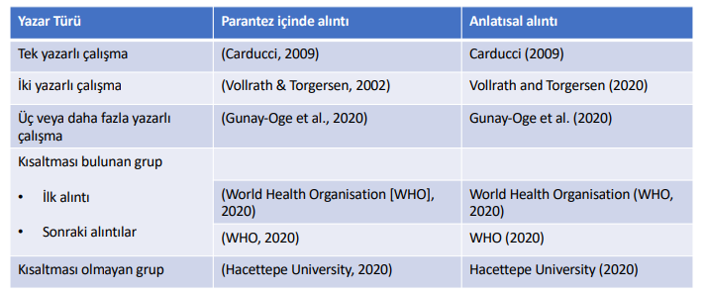

APPENDIX 2. EXAMPLES OF REFERENCING
Hacettepe University Open Course Materials (2020). APA 7 Academic Publication Principles. Retrieved from http://acikders.hacettepe.edu.tr/dersler/edebiyat_fakultesi/APA/APA.html on 16.August.2022.
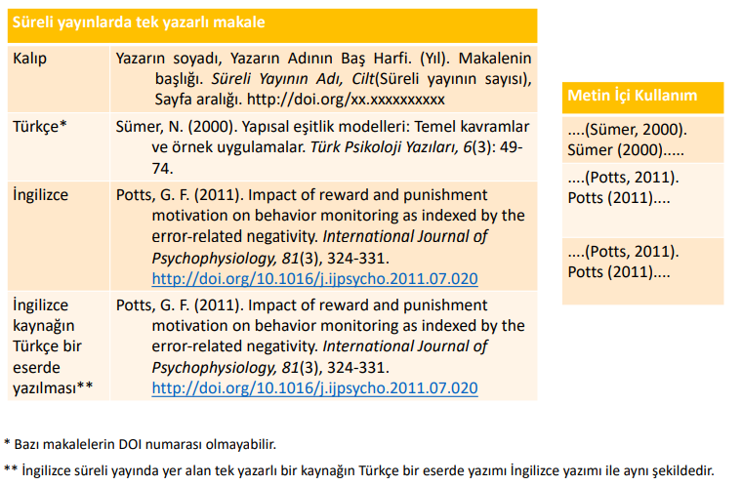
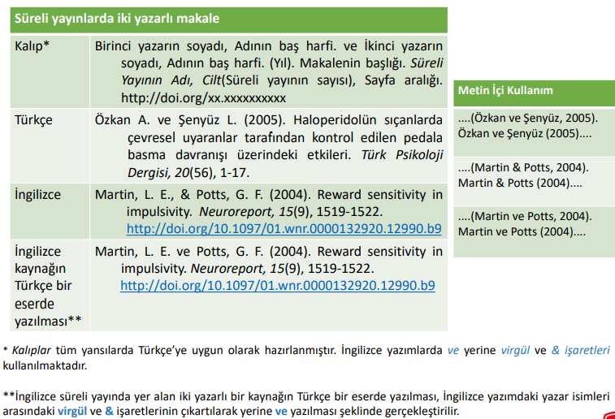
APPENDIX 2. (continue)
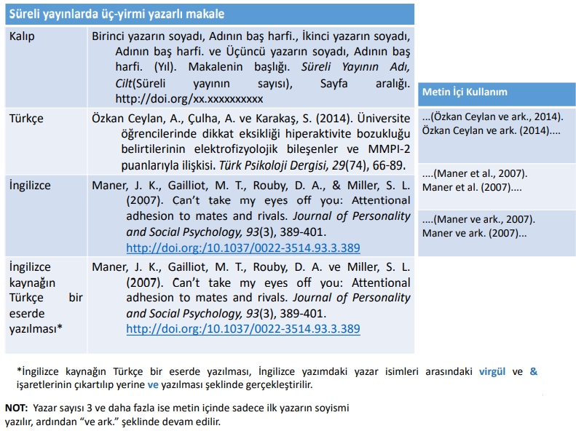

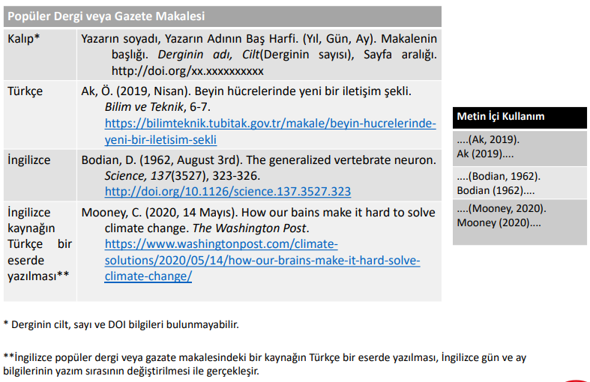
APPENDIX 2. (continue)
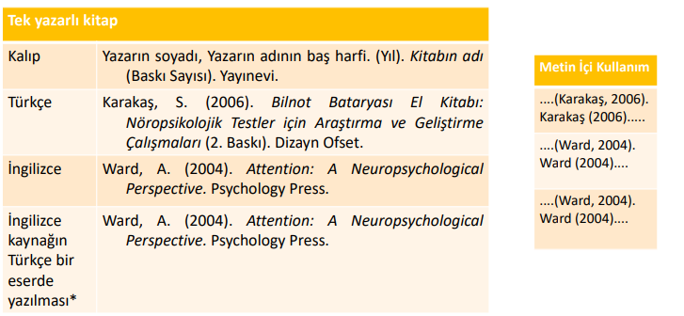

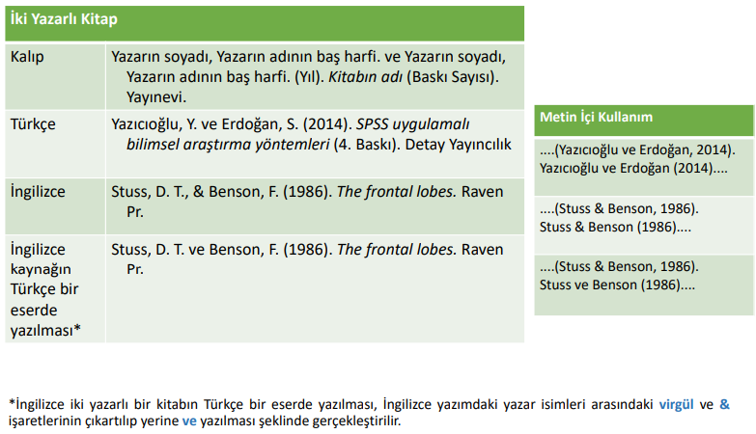

APPENDIX 2. (continue)
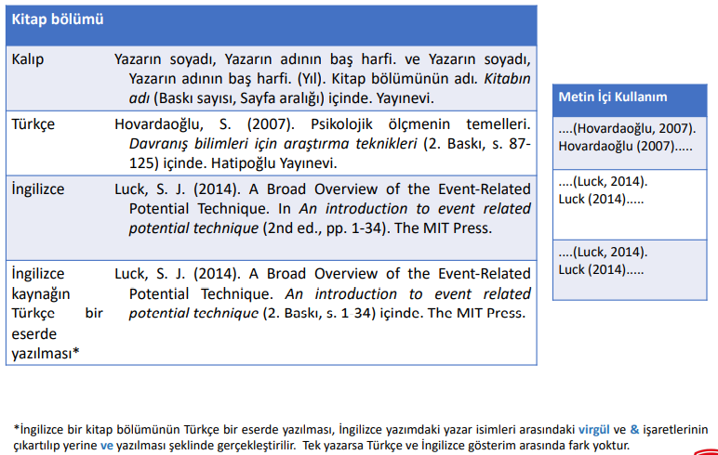

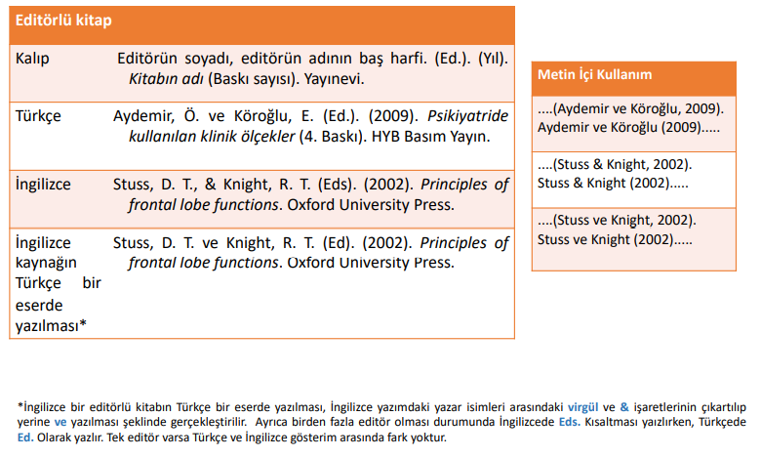

APPENDIX 2. (continue)
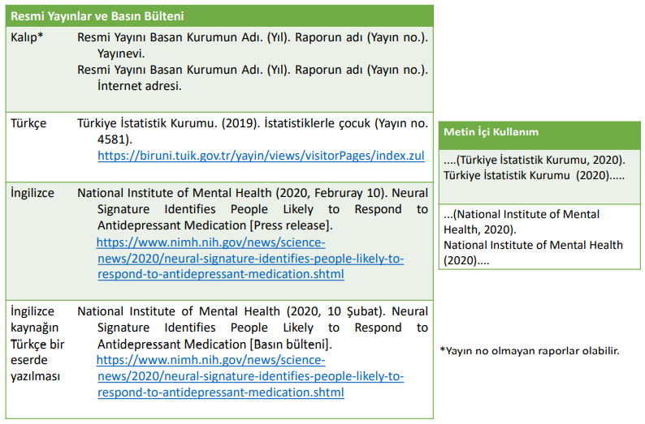

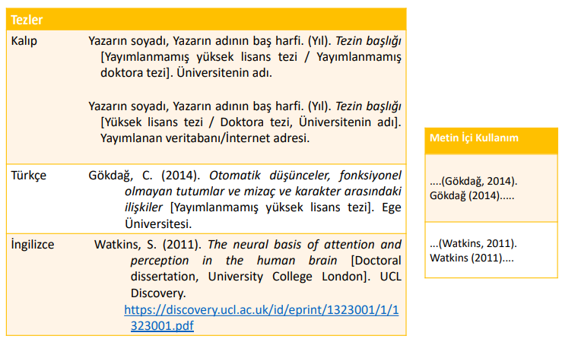

APPENDIX 2. (continue)
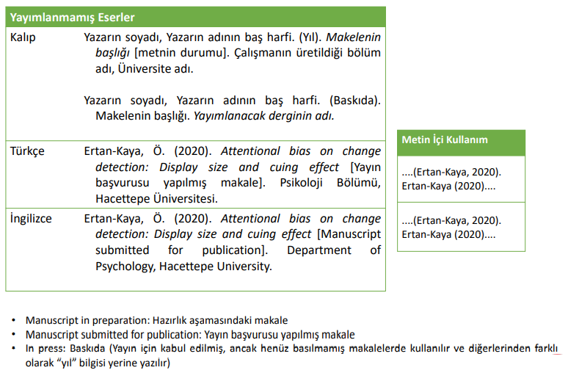

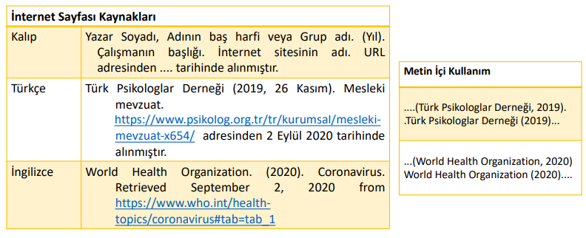

A space should be used in the writing of the footnote and if possible, the footnote should be written in a smaller font (8 or 9 points.) Footnotes should be numbered starting with 1 in order of indication. It should start with a single tab and be aligned on both sides.

